..

Microsoft Dynamics
Customer Solution Case Study
 |  |  |   Coffee Roaster Drives Productivity and Insight, Prepares Strategically for the Future

Overview  Country or Region: Canada  Industry: Consumer goods manufacturing—Food and beverage; Wholesale and distribution—Nondurable goods merchant wholesalers  Customer Profile  Oughtred Coffee and Tea is based on Vancouver Island, British Columbia, and is a coffee roaster, distributor, and equipment service provider with 45 employees and annual revenue of C$6.7 million (U.S.$6.5 million).  Business Situation  The company relied on a basic accounting package to manage operations, resulting in manual processes and an overall lack of business insight, which was needed for enhanced decision making.  Solution  The company engaged Microsoft® Gold Certified Partner The RSC Group and followed the Microsoft Dynamics® Sure Step methodology to deploy Microsoft Dynamics NAV.  Benefits  - Improve time-to-benefit with a  proven methodology  - Eliminate manual processes, save 2,000 hours a year  - Gain actionable business insight |  |  | “With Sure Step, the project has stayed within scope, and we’re already seeing the positive results we anticipated with Microsoft Dynamics NAV.”  John Oughtred, President and CEO, Oughtred Coffee and Tea
 |  |  | Based on Vancouver Island, British Columbia, Oughtred Coffee and Tea is a coffee roaster, distributor, and equipment service provider. Relying on a basic accounting package to manage operations, the company handled many processes outside the system, resulting in islands of data, data reentry, and a lack of business insight. To streamline operations and achieve the insight needed to strategically plan production and optimize its merchandising on retailers’ shelves, the company implemented Microsoft Dynamics NAV® 2009 and engaged Microsoft® Gold Certified Partner The RSC Group to drive the implementation by using the Microsoft Dynamics Sure Step methodology. After going live with core functionality in only four months, Oughtred Coffee and Tea has established the central data store needed for advanced decision making and expects to save 2,000 hours a year by reducing data reentry.
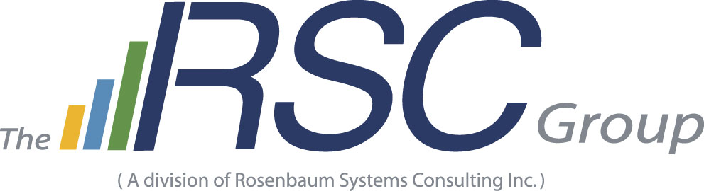 |  |  | 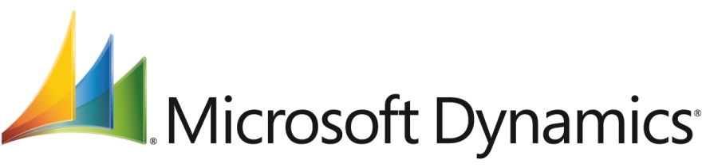

Situation
Founded in 1973, Oughtred Coffee and Tea is a coffee roaster, distributor, and equipment service provider with operations on Vancouver Island and the mainland of British Columbia. The company has six locations, 45 employees, and annual revenue of C$6.7 million (U.S.$6.5 million). Sandy Klassen, CFO of Oughtred Coffee and Tea, explains the breadth of the company’s clientele, which include over 1,200 small to large businesses: “Our customers include grocery stores that buy whole bean and retail-packaged products, food distributors, institutions, hotels, coffee bars, restaurants, and small offices that buy just a couple of cases of coffee a week.” The company also provides, maintains, and sells coffee equipment, such as espresso machines.
“With Microsoft Dynamics NAV, we’ve been able to eliminate the majority of our data reentry, which no longer requires two part-time positions; therefore, we will be able to save 2,000 hours each year.”
Sandy Klassen, CFO,
Oughtred Coffee and Tea

Sales at Oughtred Coffee and Tea generally take place in one of two ways: The company fulfills phone orders or restocks retailers’ shelves based on units sold and then invoices accordingly.
Oughtred Coffee and Tea’s
head office in Victoria,
British Columbia.
The company has traditionally relied on basic accounting software to manage operations. As a result, many processes have taken place outside the system, resulting in data reentry and an overall lack of business insight. “We had multiple, manual systems,” says Louis Li, Accounting Supervisor at Oughtred Coffee and Tea. “We had to balance all the systems, which was pure busywork without any real benefit.” In fact, data reentry at Oughtred Coffee and Tea was so intensive that the company hired two part-time workers solely to handle this process.
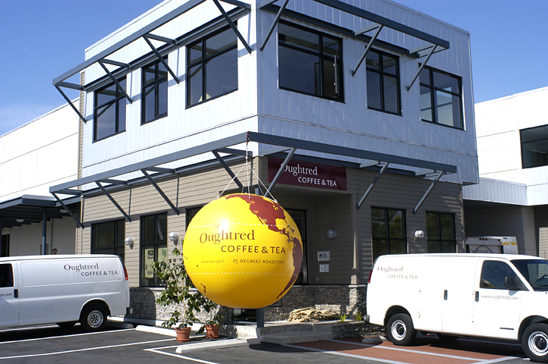

Li notes that he would spend most of his time simply performing essential tasks. “We spent over 80 percent of our time just getting the basic financial reports done—the income statement, the balance sheet, and the cash flow statement,” he says. “That left us with only 20 percent of our time to do business analysis, which most of the time was very basic because the source information was so limited.”

In addition to streamlining operations, when company leaders looked to the future, the ability to perform advanced analysis was top of mind. Says Klassen, “We wanted to be able to focus our energy on analyzing which products were selling and which ones were not so that we could optimize our inventory levels and merchandise in stock at retailers to meet demand.”

To accomplish these goals, company leaders considered an enterprise resource planning (ERP) system. They understood that with the right solution in place, they could expand beyond basic accounting to include robust, fully integrated functionality for warehouse and inventory management, service management, customer relationship management, and manufacturing. “We wanted to eliminate data reentry and centralize all our information,” summarizes Li. “Doing so would yield more timely information that would let us generate specific, detailed reports and support our company’s growth in a more efficient way.”

Solution
Oughtred Coffee and Tea considered moving to a Sage Accpac ERP solution but ultimately decided on Microsoft Dynamics® NAV 2009 for its familiar user experience and integration with other Microsoft® products and technologies that the company was already using. Says Li, “When we looked at both Accpac and Microsoft Dynamics NAV, we concluded that Microsoft Dynamics NAV was much easier for our staff to use and learn. Also, it integrates with the Microsoft Office system and other software tools we use, so we expected a smooth transition to the new solution, as opposed to what we would face with Accpac or other vendors’ products.”

The company was also attracted to the ability of Microsoft Dynamics NAV to support growth and changing business requirements, enabling a phased and more cost-effective implementation. Says Klassen, “Even if we weren’t going to use all capabilities initially, Microsoft Dynamics NAV had all the functionality we needed so that, eventually, we could support our manufacturing plant.”

A Proven Approach to ERP Implementation
To manage the implementation, Oughtred Coffee and Tea called on the expertise of Microsoft Gold Certified Partner The RSC Group. The RSC Group helped provide transparency and set clear expectations for the entire implementation process—from the initial discovery process and development of the statement of work to future change requests. And, the company took advantage of the Microsoft Dynamics Sure Step methodology, which incorporates the cumulative experience of Microsoft and its partners in deploying Microsoft Dynamics solutions.

“When we initiate a new project, the Sure Step methodology provides the road map we follow,” says Suzan Riedel, Director of Consulting for The RSC Group. “It saves us time, because we can make use of established project templates that keep us consistent.”

Helping Oughtred Coffee and Tea realize quick results from Microsoft Dynamics NAV, The RSC Group took advantage of the Rapid Implementation Methodology within Sure Step. “The legacy systems at Oughtred Coffee and Tea were extremely time intensive,” says Riedel. “The company was already so far behind on month-end reporting that we decided to perform a rapid implementation so that the company would not burn out its resources by requiring them to manage an implementation in addition to performing their own jobs.”

Role-Specific Functionality and Efficiency for Workers
After just four months, Oughtred Coffee and Tea uses Microsoft Dynamics NAV to manage core financials, purchase and sales order processing, and inventory management. Taking advantage of the multicompany capabilities of the solution, Oughtred Coffee and Tea has local deployments of the solution at each of its six branch locations, which share information on a common Microsoft SQL Server® database.

Currently, 35 of the 45 employees at Oughtred Coffee and Tea access Microsoft Dynamics NAV, with 15 employees using it regularly. These employees have roles in accounts receivable, accounts payable, accounting, distribution, and operations.

Oughtred Coffee and Tea also takes advantage of the RoleTailored user experience of Microsoft Dynamics NAV 2009. This user experience provides employees at Oughtred Coffee and Tea with Role Centers—a user interface that provides the most relevant functionality of the solution based on an employee’s role in an organization.
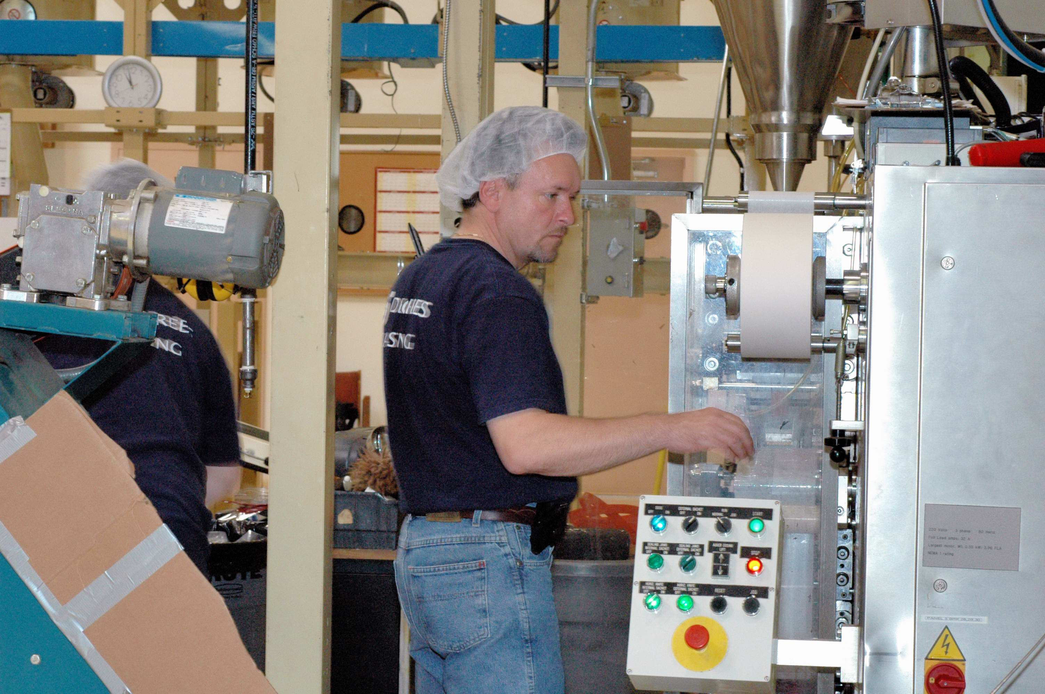
At the Oughtred Coffee and Tea roasting plant in Delta, British Columbia, a roast master operates a coffee-packaging machine.

Extending the Solution
Oughtred Coffee and Tea aims to go live with the manufacturing module of Microsoft Dynamics NAV at its 25 Degrees Roasting plant within a year. “We envision that the manufacturing functionality will aid the production schedule, and because the module is integrated with our inventory, we can then plan production based on demand,” says Li. “We also expect that this will help us be more strategic in ordering, which is still somewhat manual. Our goal is to connect the costs of raw materials and overhead to arrive at a more accurate cost for our coffee products.”

The company is also beginning to take advantage of electronic data interchange in the solution to support larger or more technology-savvy customers. In addition, the company is considering options for service delivery, such as providing truck drivers with handheld devices integrated with Microsoft Dynamics NAV that will let them post sales orders from a retail location.

Benefits
As employees continue do their jobs with Microsoft Dynamics NAV and managers assess all aspects of the business, Oughtred Coffee and Tea discovers new solution benefits every day. The company already sees improvements in productivity, accounting processes, and analytics and looks forward to further streamlining and automating operations.

Improve Time-to-Benefit with a
Proven Methodology
Both Oughtred Coffee and Tea and The RSC Group attribute the successful implementation largely to the Sure Step methodology. Says Riedel, “If we hadn’t used a methodology like Sure Step, a project like this could have easily taken two months longer.”
“We can now manage our sales department better and empower sales associates more. We see customer sales trends, set realistic targets, and set up a dependable monitoring system, which we couldn’t do before.”
Michael Oughtred, Corporate Sales Manager, Oughtred Coffee and Tea

Although the implementation proceeded in an accelerated manner, Oughtred Coffee and Tea managers always felt that the solution addressed their concerns and that they gained the results they sought. Says John Oughtred, President and CEO of Oughtred Coffee and Tea, “With Sure Step, the project has stayed within scope, and we’re already seeing the positive results we anticipated with Microsoft Dynamics NAV.”

Eliminate Manual Processes, Save 2,000 Hours a Year
Oughtred Coffee and Tea has eliminated much of its manual data reentry across multiple systems and spreadsheets. Says Klassen, “With Microsoft Dynamics NAV, we’ve been able to eliminate the majority of our data reentry, which no longer requires two part-time positions; therefore, we will be able to save 2,000 hours each year.”

Gain Actionable Business Insight
With business data from six locations available for reporting and analysis in a single repository, Oughtred Coffee and Tea has enhanced insight into operations—a benefit that is sure to improve even further as the company extends the solution to manufacturing.

“Now, we can run a weekly sales report that captures all operational data,” says Klassen. “That report is vastly different from what we had to work with in the past. We can pinpoint whether products are selling or not, whether customers are buying or not, and which products are the most profitable. With that information, we can reliably plan products, target markets, and rationalize SKUs for enhanced profitability.”

Michael Oughtred, Corporate Sales Manager adds, “We can now manage our sales department better and empower sales associates more. We see customer sales trends, set realistic targets, and set up a dependable monitoring system, which we couldn’t do before.”
Microsoft Dynamics
For More Information
For more information about Microsoft products and services, call the Microsoft Sales Information Center at (800) 426-9400. In Canada, call the Microsoft Canada Information Centre at (877) 568-2495. Customers in the United States and Canada who are deaf or hard-of-hearing can reach Microsoft text telephone (TTY/TDD) services at (800) 892-5234. Outside the 50 United States and Canada, please contact your local Microsoft subsidiary. To access information using the World Wide Web, go to:
www.microsoft.com

For more information about Oughtred Coffee and Tea products and services, call (877) 384-7444 or visit the Web site at:
www.oughtred.com

For more information about The RSC Group products and services, call (888) 290-3267 or visit the Web site at:
www.rsc.com
This case study is for informational purposes only. MICROSOFT MAKES NO WARRANTIES, EXPRESS OR IMPLIED, IN THIS SUMMARY.

Document published October 2009

Software and Services  - Microsoft Dynamics  - Microsoft Dynamics NAV 2009  - Solutions  - Microsoft Dynamics Sure Step | Partners  - The RSC Group

Microsoft Dynamics is a line of integrated, adaptable business management solutions that enables you and your people to make business decisions with greater confidence. Microsoft Dynamics works like familiar Microsoft software such as Microsoft Office, which means less of a learning curve for your people, so they can get up and running quickly and focus on what’s most important. And because it is from Microsoft, it easily works with the systems that your company already has implemented. By automating and streamlining financial, customer relationship, and supply chain processes, Microsoft Dynamics brings together people, processes, and technologies, increasing the productivity and effectiveness of your business, and helping you drive business success.

For more information about Microsoft Dynamics, go to:
www.microsoft.com/dynamics

